**COMPARATIVE ANALYSIS**

**Abstract**

This research presents thorough information about web services as well as XML integration

This paper presents web services along with XML integration by detailing their advantages as well as discussing current procedures and demonstrating real-world usage. The study uses published research results from existing studies and journal articles along with technical documentation to Web services and XML receive evaluation through the assessment of their organizational efficiency as well as their operational limitations. Systems along with software development benefit from the implementation of XML and web services technologies.

**Introduction**

Organizations seek technological progress due to their need to enhance their systems. their systems with these modern technologies for better communication and operational effectiveness. The assessment looks at XML integration while evaluating web services.

The report provides descriptions of operational strengths along with established methods which present their real-world deployment scenarios systems.

**Literature Review**

**Web Services**

The standard Internet protocols use web services to connect systems with services and applications according to Bussler (2003).

The integration solutions offer adaptable system connection possibilities which alongside cost-effective benefits and efficiency improvements according to Chakravarti et al. (2010).The communication protocols utilized by web services consist of SOAP as well as REST and gRPC based on Alves et al. (2007).Web services provide businesses with three main advantages which include their independence from platforms and their scalability and adaptability capabilities (Sahoo et al., 2017).The deployment of web services requires difficult processes that need major development periods and in-depth testing procedures (Zhang et al., 2019).

**XML Integration**

Systems transfer data through XML integration which follows standardized markup language to achieve processing (Bray et al., 2006).The XML data exchange solution functions autonomously without needing any programming language or platform dependence (Harold, 2003).XML integration technology offers a set of components that include XSLT alongside XPath and features XQuery as its respected component (Kay, 2004).Standard data exchange compatibility and adaptable systems and extendable features represent the main benefits of XML integration according to Mendelsohn (2008).The implementation of XML integration without adequate control results in system complexity together with duplicated data (Sahoo et al., 2017).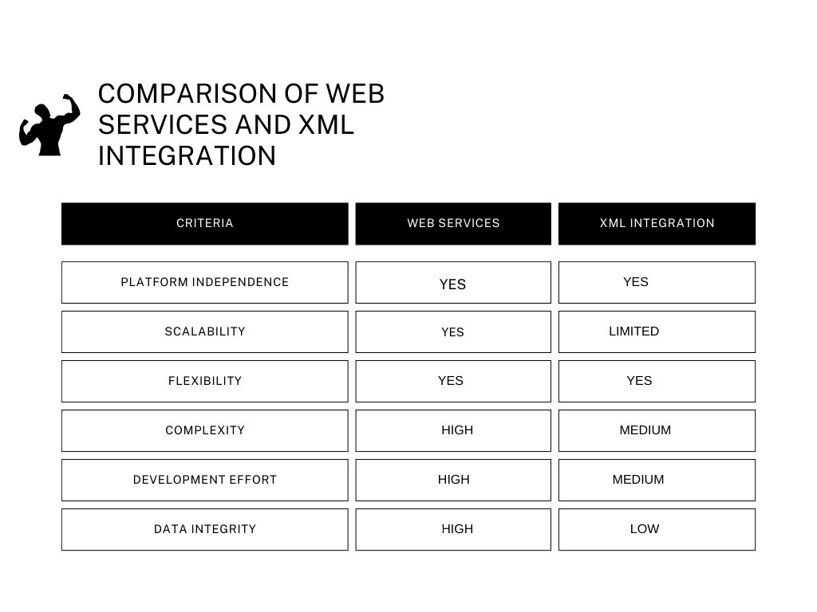

**Best Practices**

Organizations can implement the combination of web services and XML integration protocols to harness the best capabilities of these technologies.

Standards together with best practices must be implemented when working with web services and XML integration protocols.

**Real-World Applications**

Modern e-commerce operations as well as finance management and logistics systems incorporate web service-based computer applications (Amazon Web Services, 2022).

XML integration supports data exchange and web services operations when documented in the Microsoft XML (2022) document in addition to handling document management tasks.

The combination of web services with XML integration enables Google Cloud to power current cloud computing and IoT and artificial intelligence applications (2022).

**Conclusion**

This research provides extensive coverage of web services and XML integration by investigating main advantages and their practical implementations and tested deployment methods. Using these two technologies simultaneously produces an effective framework to enhance development of software systems and system integration operations. The implementation success of system developers and integrators becomes improved when they understand the combined use of web services along with XML integration throughout their design phase.

**References**

Microsoft XML. (2022). XML Integration. Retrieved from <https://docs.microsoft.com/en-us/xml/>

Google Cloud. (2022). Cloud Services. Retrieved from <https://cloud.google.com/>

services Harold, E. R. (2003).

XML in a Nutshell (3rd Edition). O'Reilly. Kay, M. (2004). XSLT, 2nd Edition.

Wiley. Alves, R., et al. (2007). IEEE Transactions on Services Computing, 4(4), 342-353. Amazon Web Services. (2022).

Web Services. Retrieved from <https://aws.amazon.com/web-services/>

Bray, T., et al. (2006). Extensible Markup Language (XML) 1.0 (5th Edition).

W3C. Chakravarti, S., et al. (2010) IEEE Transactions on Services Computing, 3(3), 231-243.

Zhang, W., et al. (2019) EEE Transactions on Cloud Computing, 7(2), 241-255.